Introduction Form
As part of your subscription, you can add two complimentary introductory cards for each course or microlesson. These cards are a great way to:
- Share messages from leadership (either in video or in text)
- Provide important company specific information
- Explain why you have partnered with Emtrain

Client:
Lesson Title:

Instructions
This document will walk you through adding up to two different introduction cards to a lesson of your choice.

Overview: You are asked to provide the following in this document:
- Introduction (One – Two Cards)
  - Please select your option:
1 video card
1 text card
2 text cards
2 videos cards
1 video card and 1 text card
1 text card and 1 video card

General Guidelines
Text Card Limitations: Please pay particular attention to the limitations on the length of text for each card. If you plan to translate the text, you should avoid taking the full amount of space available for your English text. This is because many languages consume up to 30% more space than English.

Video Specifications: Please submit your video in .mp4 format with a recommended resolution of 1920x1080 pixels. More content submission guidelines can found here.

Return Completed Form: Once completed, return this 1) form, 2) Video file in .mp4, and 3) transcript (if intended) to your implementation manager, client success manager, or production@emtrain.com.

Video Introduction Card (Card One)
Yes, we are providing a video introduction
No, we are not providing a video introduction
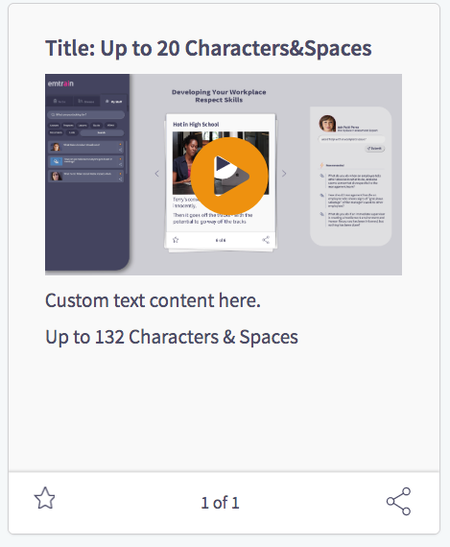
Card Title (Maximum 20 characters and spaces):

Card Body (Maximum 132 characters and spaces):
Type Here

Emtrain clients can insert a text introducing their custom video

For video submissions, please submit the video file AND the video transcript:
Name of attached MP4 file video introduction:
Name of attached video transcript:

Text Introduction Card (Card One)
Yes, we are providing a text introduction
No, we are not providing a text introduction
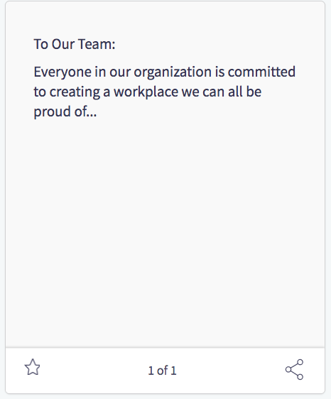
Card Body (Maximum 296 characters and spaces):
Emtrain clients can insert a text introduction by their CEO or other leaders here for content.

Select the background image for your text introduction card here.

1. 2. 3.




Video Introduction Card (Card Two)
Yes, we are providing a video introduction
No, we are not providing a video introduction
Card Title (Maximum 20 characters and spaces):

Card Body (Maximum 132 characters and spaces):
Type Here

Emtrain clients can insert a text introducing their custom video

For video submissions, please submit the video file AND the video transcript:
Name of attached MP4 file video introduction:
Name of attached video transcript:

Text Introduction Card (Card Two)
Yes, we are providing a text introduction
No, we are not providing a text introduction
Card Body (Maximum 296 characters and spaces):
Emtrain clients can insert a text introduction by their CEO or other leaders here for content.

Select the background image for your text introduction card here.

1. 2. 3.

