Dynamic Group Examples
Recommended Annual Preventing Workplace Harassment Group Configurations

Existing Non-Supervisors (non-IL): Will receive Preventing Workplace Harassment 12 — US60A (Annual) (T)
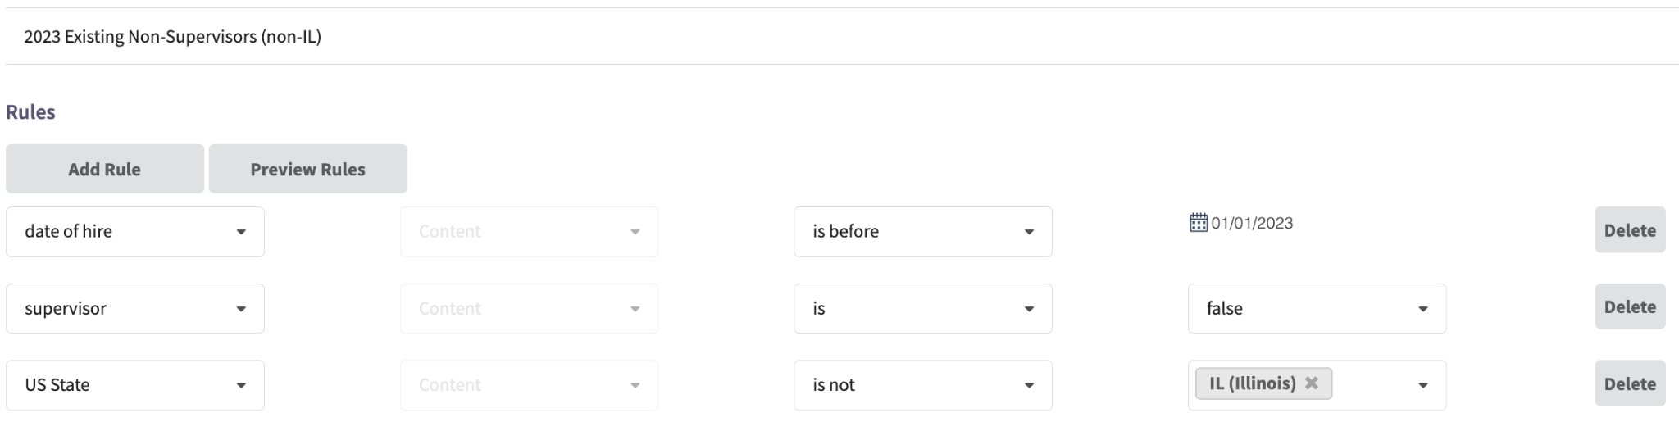
Existing Supervisors (Non-IL): Will receive Preventing Workplace Harassment 12 — US60A (Annual) (T)
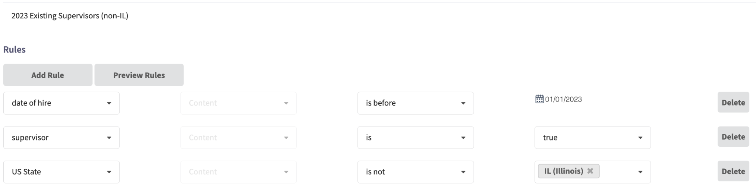
IL Non-Supervisors: Will receive Preventing Workplace Harassment 12 — US60A (Annual) (T) + bystander training
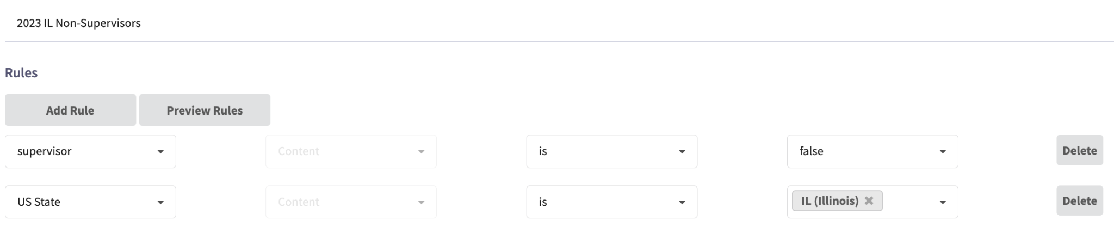
IL Supervisors: Will receive Preventing Workplace Harassment 12 — US120AB (Biennial) (T) + bystander training
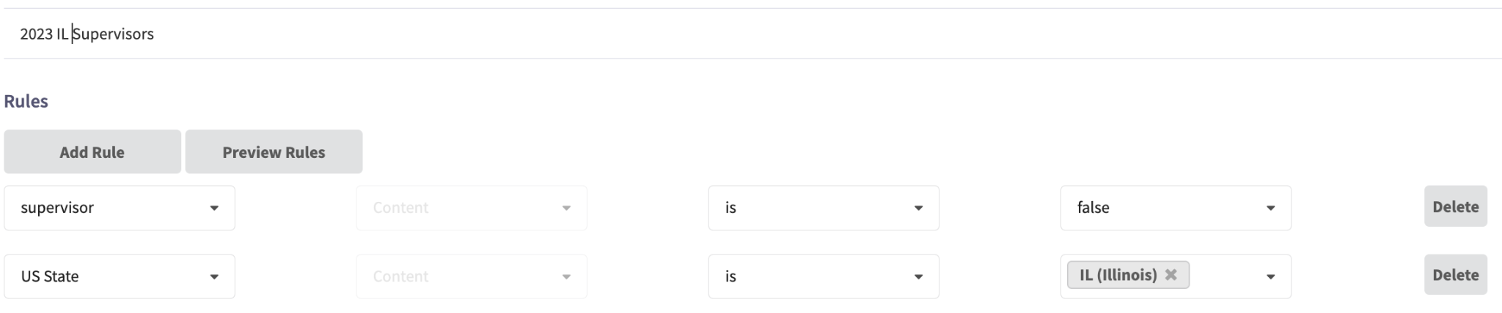
New Hires (CA,CT): Will receive Preventing Workplace Harassment 12 — US120AB (Biennial) (T)
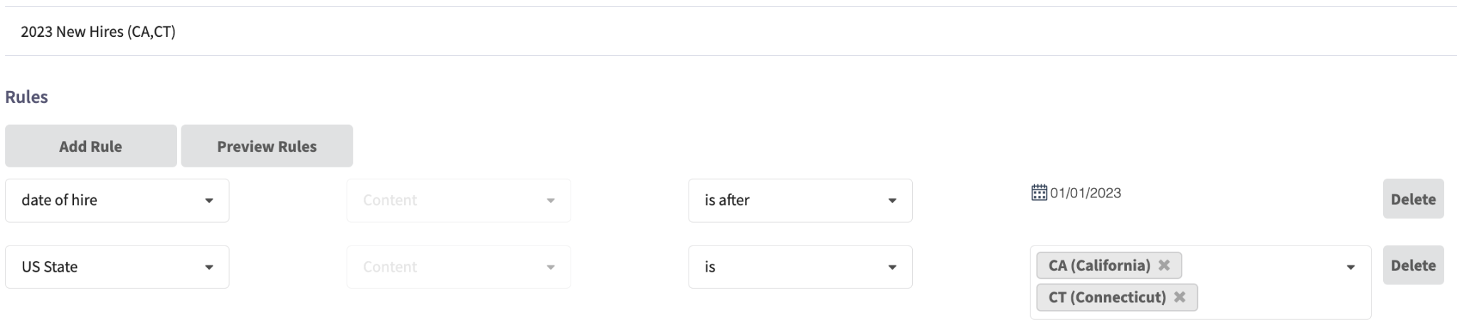
New Hires (non-CA,CT,IL): Will receive Preventing Workplace Harassment 12 — US60A (Annual) (T)
