Dynamic Group Examples
Common Dynamic Groups (One-Offs, Excluding Users, Custom Fields)

One-Offs:
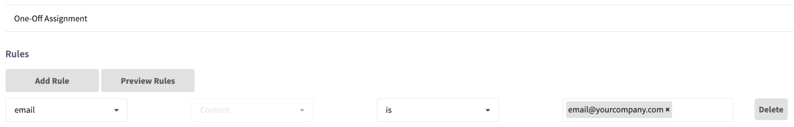

Excluding Users:
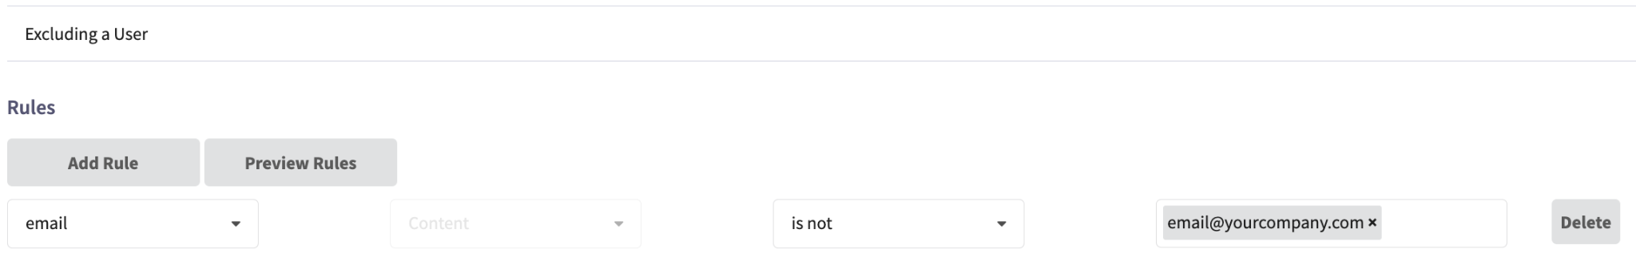

Custom Fields:

